- Install nginx and run nginx on port number 81.
sudo yum install nginx
sudo systemctl status nginx
sudo systemctl enable nginx
sudo systemctl status nginx
cd /usr/share/nginx/html/
/user/share/nginx/html
vi index.html
cat /etc/nginx/nginx.conf
vi /etc/nginx/nginx.conf
cat /etc/nginx/nginx.conf
vi /etc/nginx/nginx.conf
sudo systemctl restart ngin
sudo systemctl status nginx
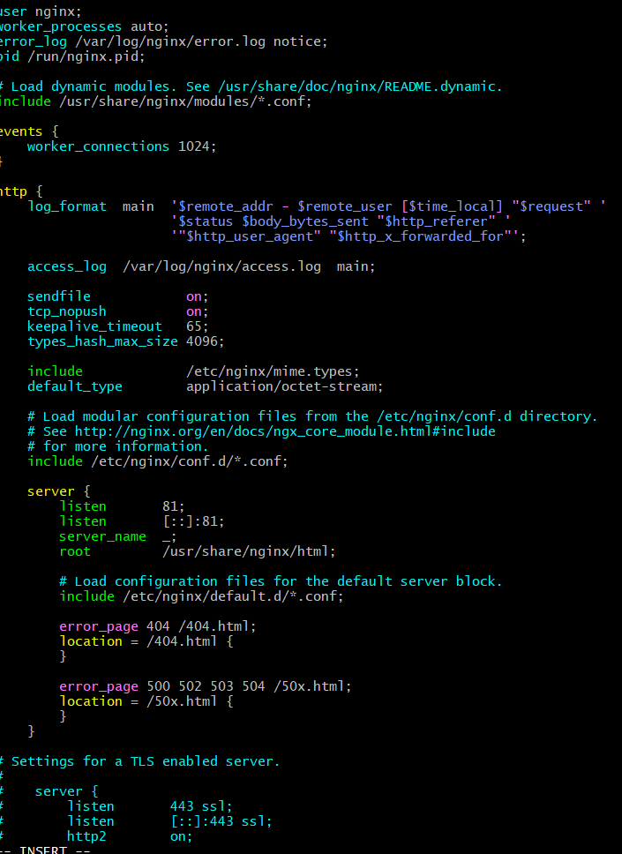
Work on port 81

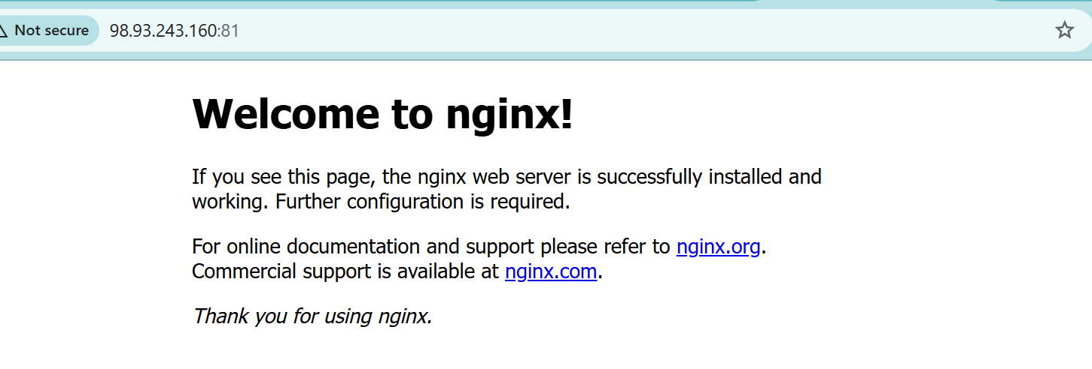
- Deploy a sample index.html file on nginx.
Deployed sample file on nginx
vi index.html
sudo restart nginx
sudo systemctl restart nginx
sudo systemctl status nginx

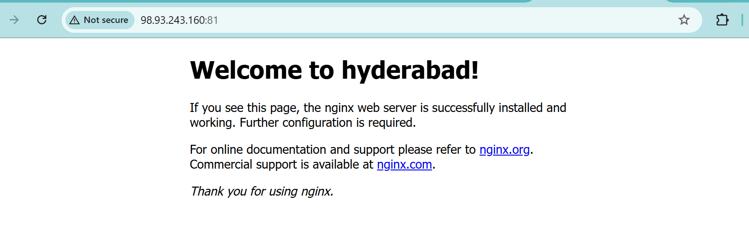
- Install Apache and run Apache on port number 82
sudo yum install httpd -y

sudo nano /etc/httpd/conf/httpd.conf

sudo systenctl restart httpd

sudo systemctl restart httpd

sudo systemctl enable httpd

sudo systemctl status httpd

vi /etc/httpd/conf/httpd.conf

sudo netstat -tuln | grep 82

sudo ss -turn | grep 82

sudo systemctl restart httpd

sudo systemctl status httpd



- Deploy a sample index.html file on Apache.
cd /var/www/html

sudo vi index.html

sudo restart httpd

sudo systemctl restart httpd

sudo systemctl statrt httpd

sudo systemctl start httpd

sudo systemctl status httpd

cd /var/www/html
sudo systemctl status httpd

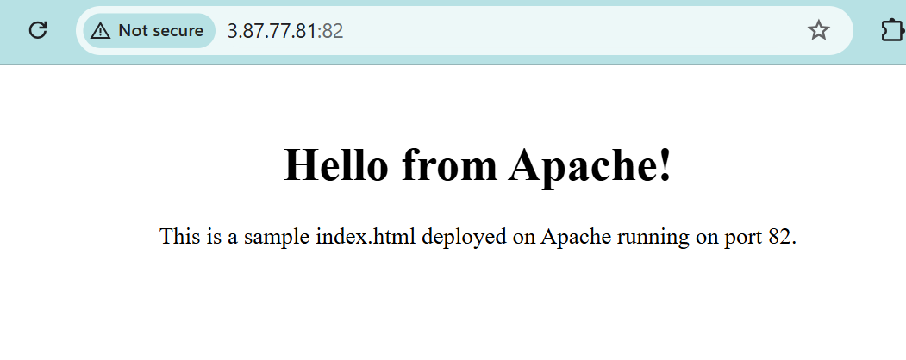
- Install Apache tomcat on port number 8082
Install tomcat
sudo yum install java-17-openjdk -y
cat /etc/os-release
sudo dnf install java-17-amazon-corretto -y
java -version
cd /opt
sudo wget https://downloads.apache.org/tomcat/tomcat-10/v10.1.31/bin/apache-tomcat-10.1.31.tar.gz
sudo tar -xvzf apache-tomcat-10.1.31.tar.gz
cd /opt
sudo wget https://dlcdn.apache.org/tomcat/tomcat-10/v10.1.34/bin/apache-tomcat-10.1.34.tar.gz
sudo tar -xvzf apache-tomcat-10.1.34.tar.gz
sudo nano /opt/tomcat/conf/server.xml
cd /opt
sudo wget https://dlcdn.apache.org/tomcat/tomcat-10/v10.1.48/bin/apache-tomcat-10.1.48.tar.gz
sudo wget https://archive.apache.org/dist/tomcat/tomcat-10/v10.1.48/bin/apache-tomcat-10.1.48.tar.gz
sudo tar -xvzf apache-tomcat-10.1.48.tar.gz
sudo mv apache-tomcat-10.1.48 tomcat
ls
sudo nano /opt/tomcat/conf/server.xml

sudo chmod +x /opt/tomcat/bin/*.sh
cd /opt/tomcat/bin
sudo ./startup.sh
sudo firewall-cmd --permanent --add-port=8082/tcp
sudo firewall-cmd --reload
sudo nano /opt/tomcat/conf/server.xml
cd /opt/tomcat/bin
sudo ./startup.sh
cd pache-tomcat-9.0,109
ls
sudo netstat -tulnp | grep 8082
cd /opt/tomcat/bin
sudo ./startup.sh
sudo tail -f /opt/tomcat/logs/catalina.out
sudo vi /opt/tomcat/conf/server.xml
curl http://localhost:8082
sudo netstat -tulnp | grep 8082
sudo tail -20 /opt/tomcat/logs/catalina.out
sudo vi /opt/tomcat/conf/server.xml
cd /opt/tomcat/bin
sudo ./startup.sh
sudo tail -f /opt/tomcat/logs/catalina.out
sudo netstat -tulnp | grep 8082

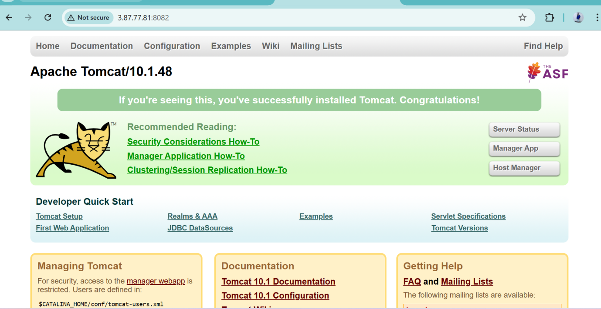

- Deploy a sample app on webapps
Go to the browser and copy the link of sample file
ls
cd ..
cd
cd ..
cd
cd /opt/tomcat/webapps
ls
wget https://tomcat.apache.org/tomcat-7.0-doc/appdev/sample/sample.war
ll

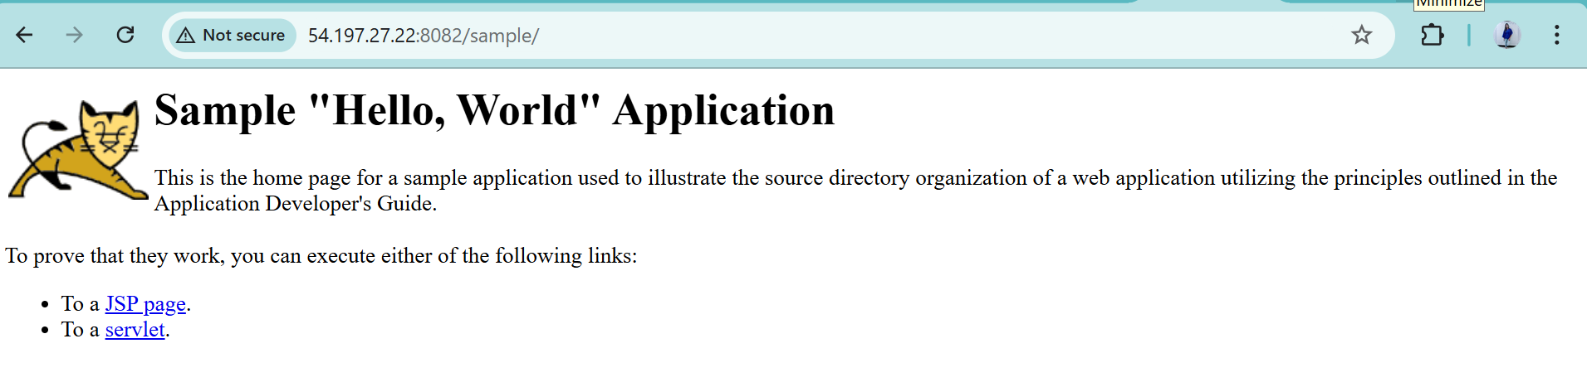

Create a tomcat.service file for tomcat.
sudo vi /etc/systemd/system/tomcat.service
sudo systemctl start tomcat
sudo systemctl enable tomcat
sudo systemctl status tomcat
cat /etc/systemd/system/tomcat.service
stop tomcat
sudo systemctl stop tomcat
sudo systemctl start tomcat
sudo systemctl status tomcat

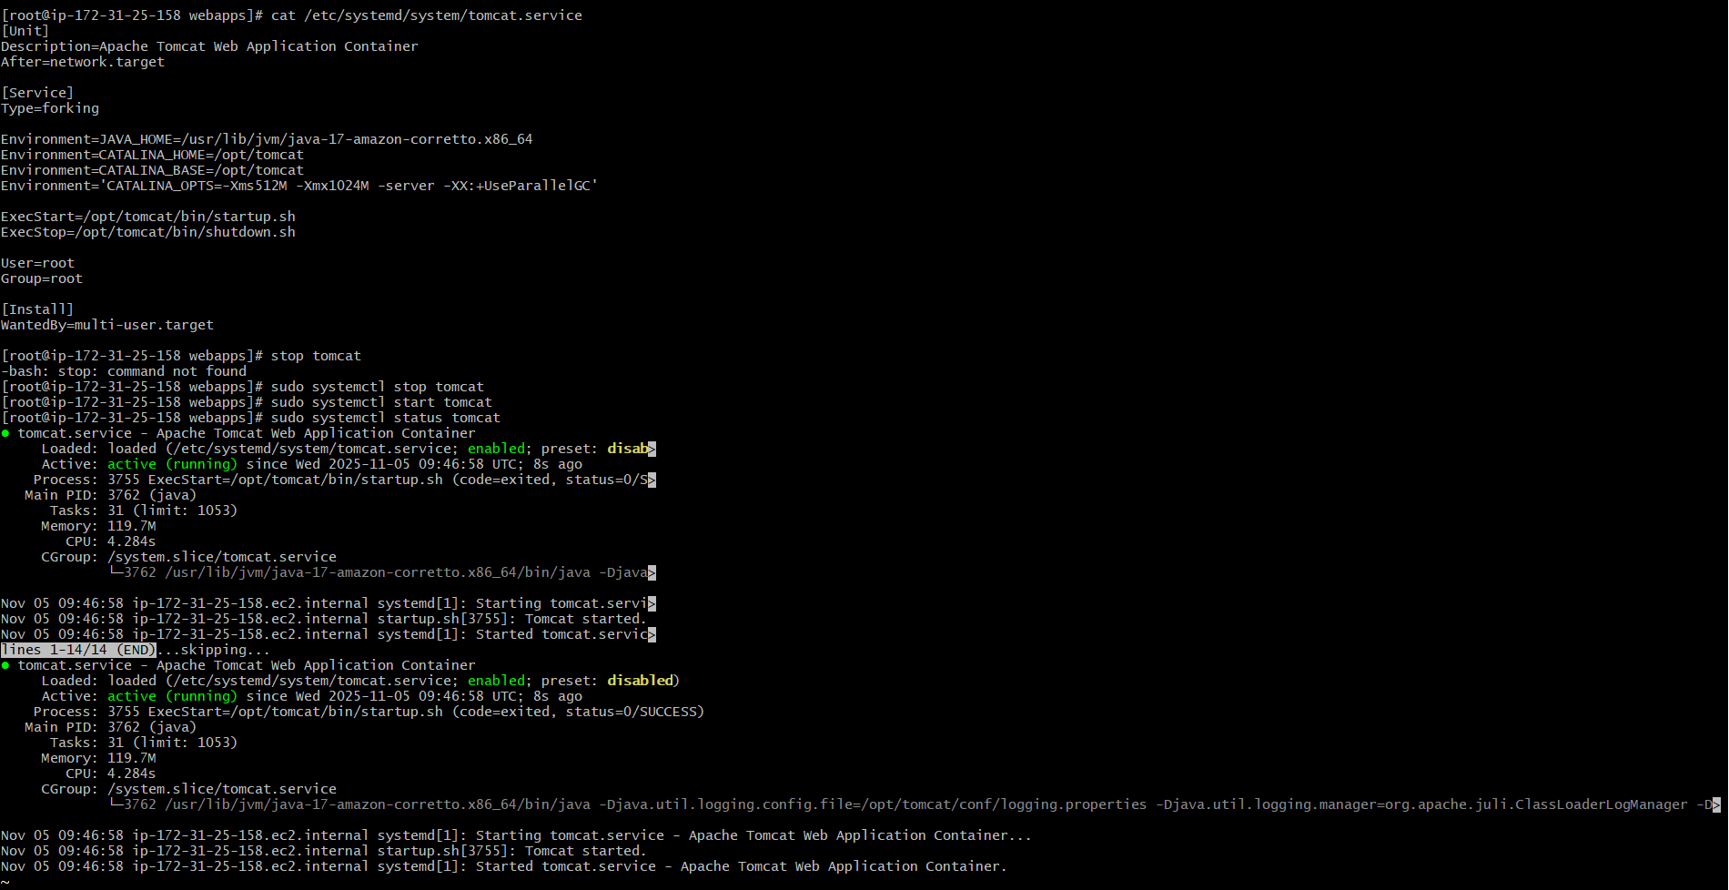

Configure HA Proxy server
Install 3 instance
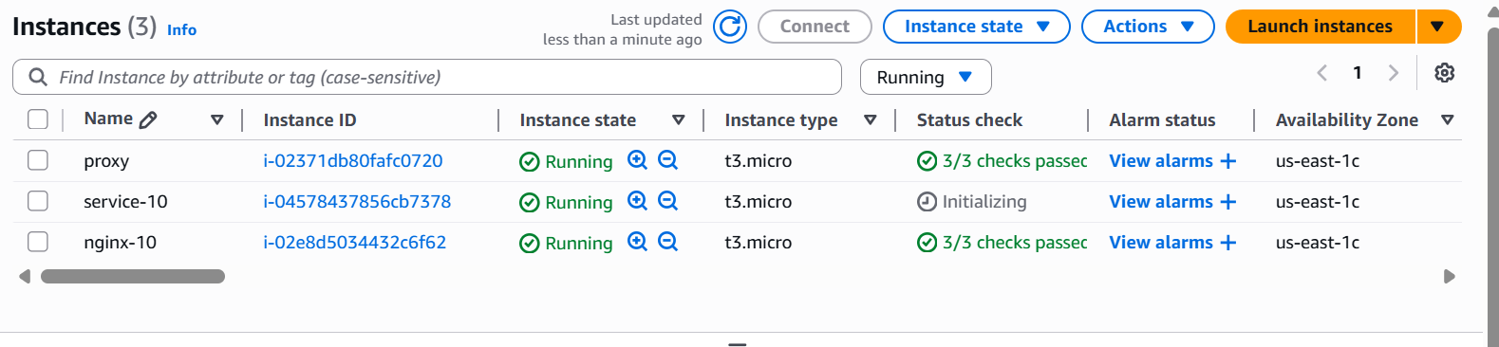
Connect the server-1
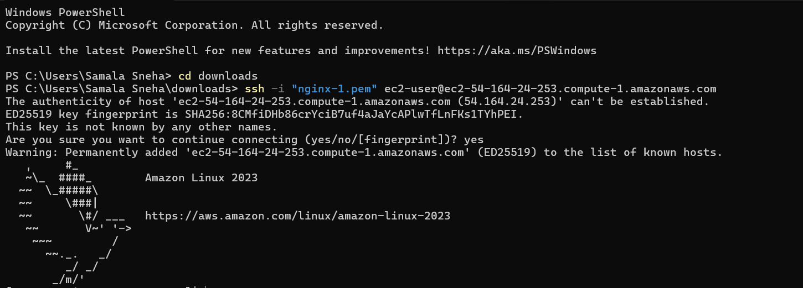
Change to root ruser
Sudo su -
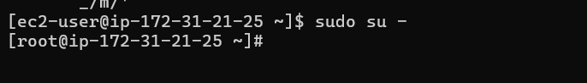
Install httpd -y
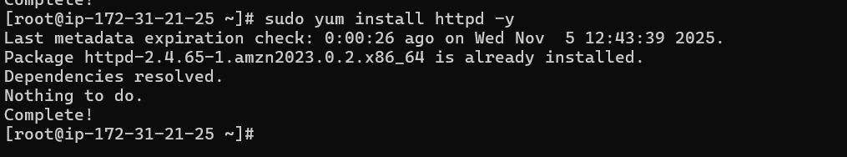
Vi /etc/hosts
Past it proxy public id
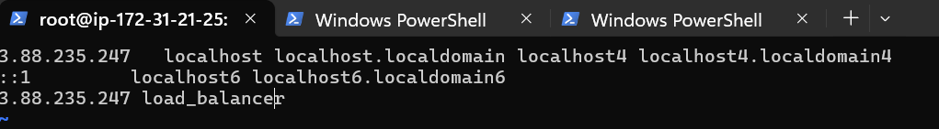
Ping load_balancer -c 4
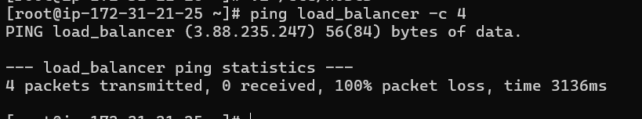
Brouse with server -1 IP

Connect to the server-2
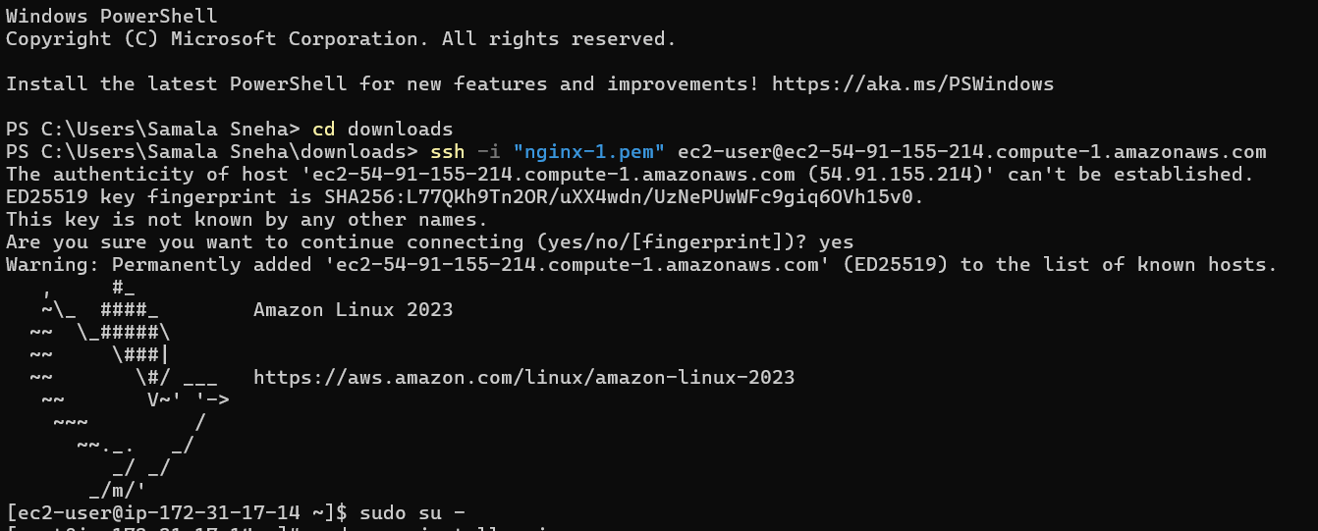
Install nginx
Sudo yum install nginx -y
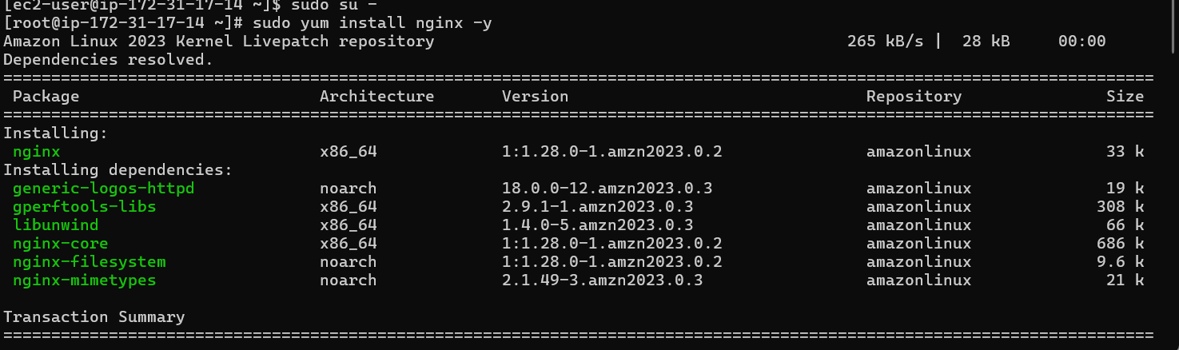
Vi /etc/hosts
Past public adress of proxy
Ping loab_balancer -c 4 : it will check net work connectivity
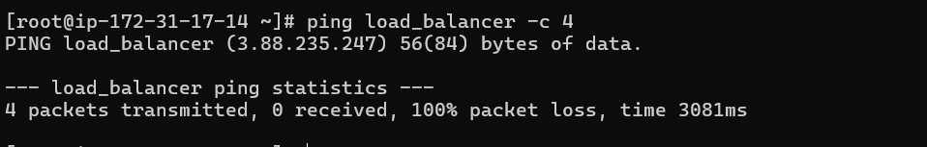
Start and check status of nginx
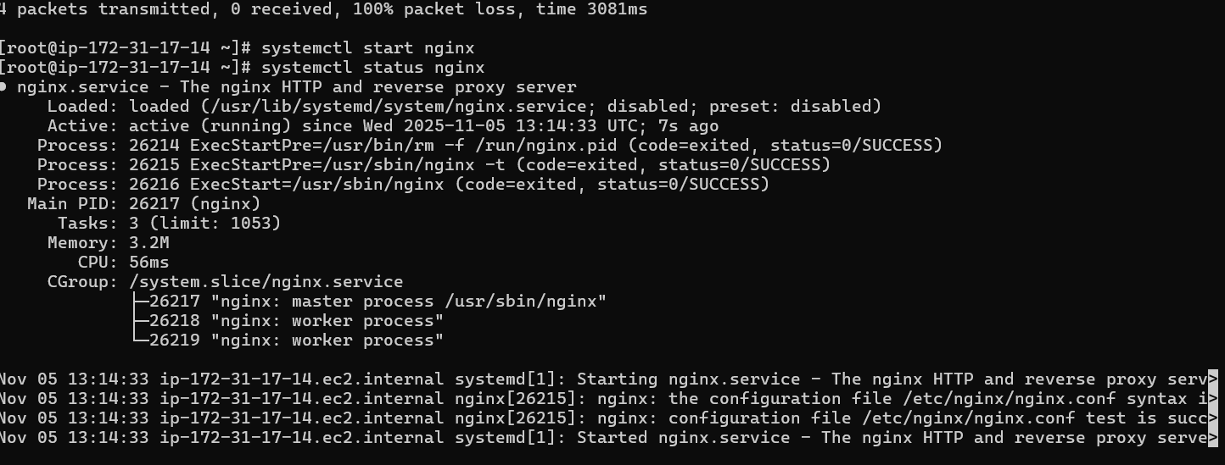
Then browse with IP adress of nginx server
It will work

Connect proxy server to terminal
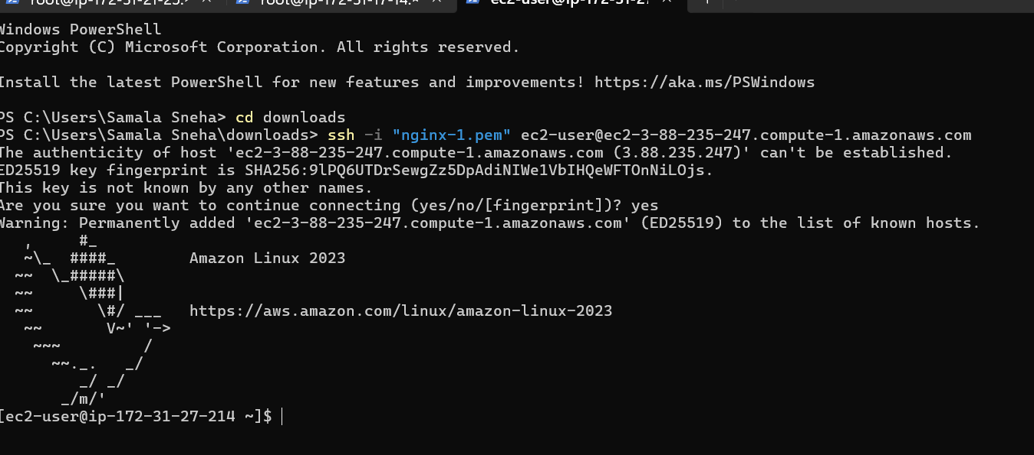
Go to root user with the help of commend sudo su -
Yum update -y
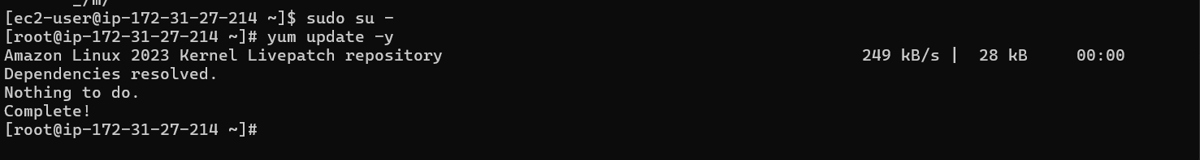
Install haproxy -y
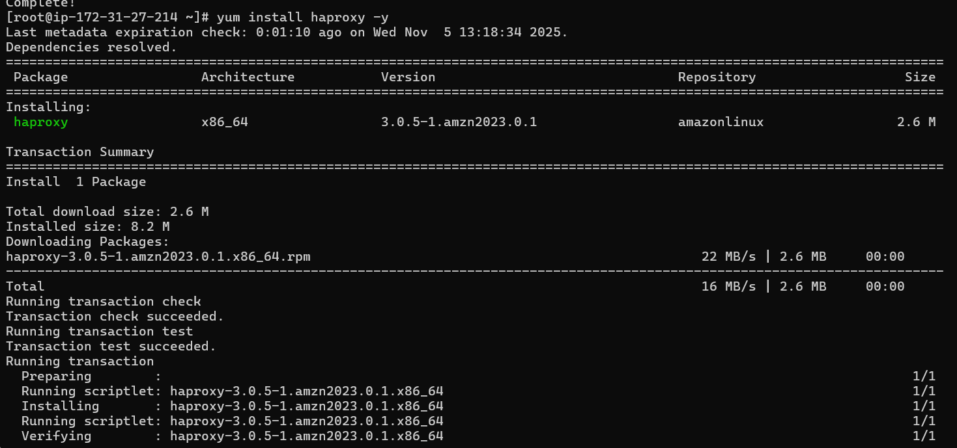
Paste 2 servers of IP address with names
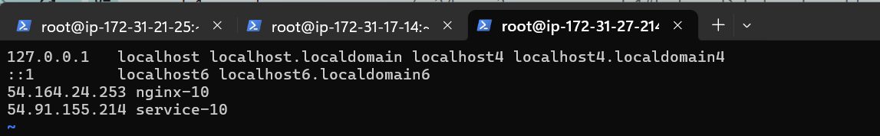
Vi /etc/haproxy/haproxy.cfg
Add 2 servers of IP
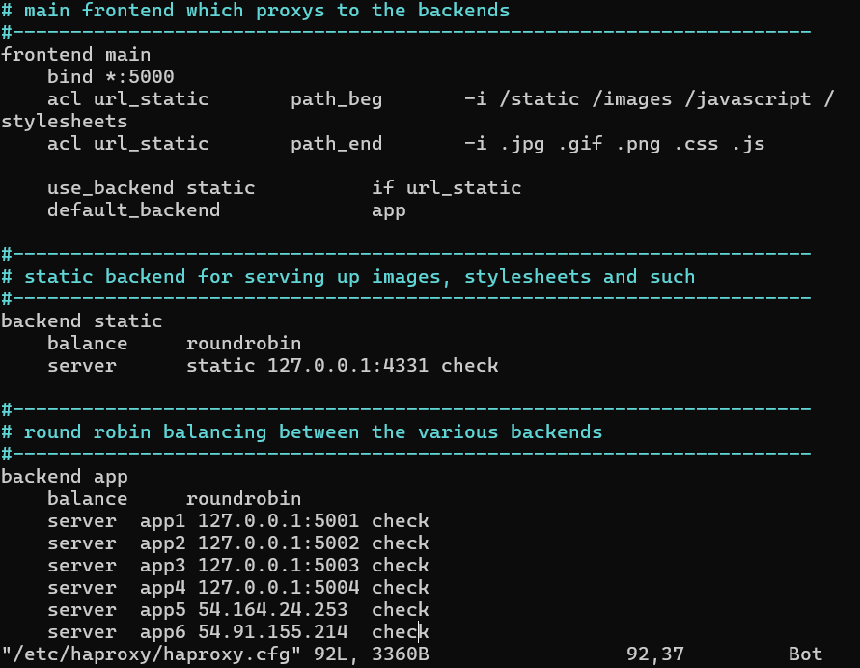

Start haproxy
Check status of haproxy
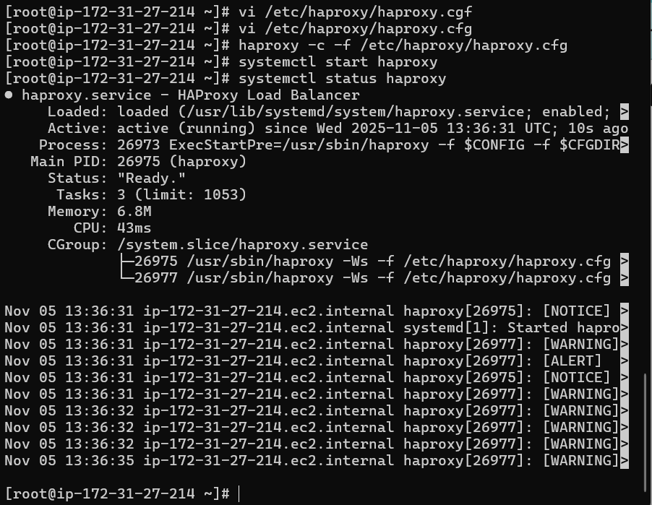
Go to the browser paste haproxy IP address
Finally its working


